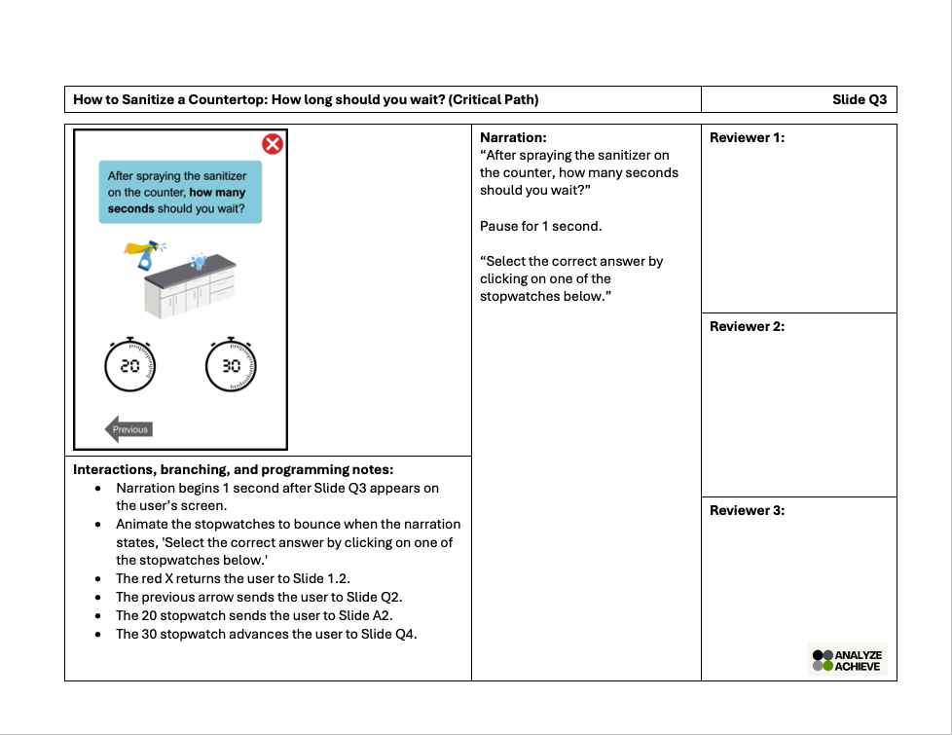
Title: (label critical path if applicable)
Slide #
Narration: (Include file names if available)
Interactions, branching, and programming notes:
(Describe which slide each trigger leads to)
(Insert image(s), descriptions, and file name(s) along with any onscreen text)
Reviewer 1:

Reviewer 2:

Reviewer 3:

